28 September 2023

Good morning,

We are getting in touch to let you know about the new #WorthSaving campaign that has recently been launched across Hertfordshire to encourage residents to save money, by saving food and reducing waste. We ask that you share information about the campaign with your community to help everyone make savings.

The facts
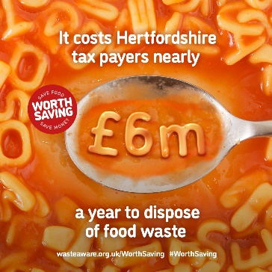
Research in Hertfordshire shows that a staggering 24% of an average ‘black bag’ refuse bin is food that could have been eaten – not peelings and eggshells, but edible food. In fact, 50-70% of the food we throw away could have been eaten. Whilst most of us believe we don’t waste much food; the figures show a different picture. Around 40,000 tonnes of edible food are thrown away in Hertfordshire each year, which equates to 66 million meals. In fact, by reducing the amount of food we throw away, each household could save up to £720 a year and we could reduce up to 10% of global greenhouse gas emissions.

The campaign
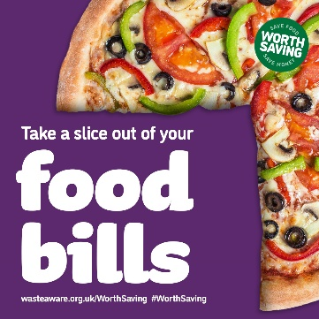
Reducing how much food we throw away is easy! The new #WorthSaving campaign outlines the 4 Steps to Save food waste and save money by tweaking your existing habits in small ways, such as by sticking to your shopping list, eating your leftovers and freezing excess food. You can view the 4 steps to save on the #WorthSaving webpage.
You could also win a free meal out by tucking in – simply subscribe to an email for 5 weeks to receive hints and tips on making the most of your food. Completing a quick survey at the beginning and end of the 5-week newsletter gives you entry into a prize draw to win a cooking experience and meal out, paid for by the Hertfordshire Waste Partnership. Full terms and conditions are online. Join the newsletter via the campaign webpage.

Support provided
As part of the Partnership, East Herts Council can provide you with digital copies of leaflets and posters to share with your group, to help share the #WorthSaving message. If you are interested in receiving the leaflets and/or posters in either digital format or hard copies, please email wasteandrecycling@north-herts.gov.uk
I hope this is of interest to you and that you recognise the importance of saving food in order to save money and reduce greenhouse gas emissions.

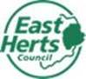 |  | Victoria Mullins  Communications and Digital Media Officer  East Herts District Council  07925 035831  Sign up to our weekly newsletter - Network  

